**Tour Singapore 4 Days 3 Nights**

*Attention:*

-Departure point: Hanoi.

-Time: 4 days 3 nights.

-Media: aircraft.

-Price: 11800000đ.

-Images:

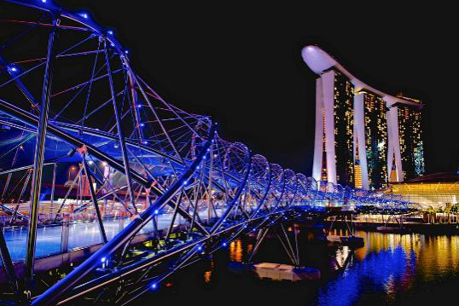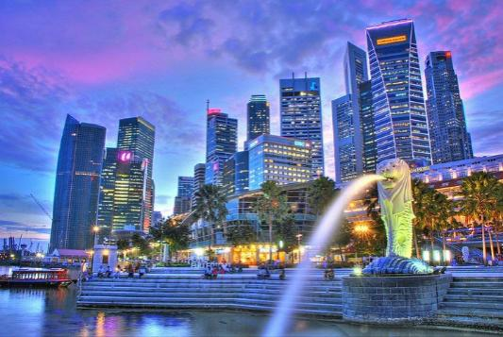

1. **Introduce:**

**SINGAPORE TOUR 4 DAY 3 NIGHT**

Singapore is a country in Southeast Asia, with a majority of people of Chinese descent, so the Singapore Lunar New Year has many similarities with Vietnam. Coming to Singapore this time, you will see Singapore as being dressed in a new extremely colorful shirt. In addition, you also have the opportunity to participate in special festivals such as the Lighthouse Festival, Singapore River Hongbao Festival and Chingay Street Festival and many other activities.

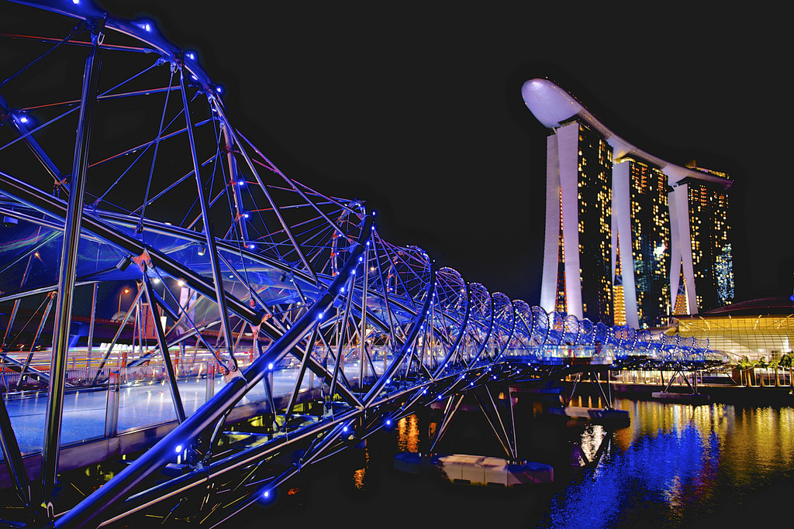

**II.Tour schedule:**

**1.Day 1:**

**HaNoI – SINGAPORE** _____________________________________________________________________

06h00: Car and HDV pick you up at the meeting point of departure to Singapore on flight VJ915 (09: 35-13: 55). You have lunch on the plane.

13h55: Arrive at Changi Airport - Singapore, the airport is known as the best airport in the world with 06 botanical gardens, the airport is fully equipped with services such as music room, swimming pool, entertainment area, hotel, shopping center ... Car and HDV pick you up to visit the historic Parliament Building, Supreme Court, City Hall, Esplanade Theater, Marina Bay Bay, Merlion Park Sea Lion Park.

Then the car and HDV pick you up to the hotel to check in and rest. Overnight at 3 * IBIS NOVENA HOTEL or similar. The group have dinner in restaurant.

After dinner you can join local guides freely to explore Singapore nightlife program "Singapore by Night" attractive and new as: Discover the underground life of Singaporeans by China MRT, Experience Singapore River Cruise on Marina Bay at night, Explore Suntec City - learn about Feng Shui _____________________________________________________________________

**2.Day 2:**

**SINGAPORE – SENTOSA** _____________________________________________________________________

After breakfast buffet at the hotel Car and guide welcome the delegation to visit Buddha Tooth Pagoda - Located in China Town, with magnificent architecture, considered as a Museum of modern Buddhist art. Here you can learn about the history and philosophy of Buddhism through the works of art. Go to the top of Mount Faber Mounta - the highest peak of Singapore to enjoy the panoramic view of Singapore Harbor. Visit and shop at:

Jewelry shops, shops,

Shop stores + Collagen skin care - traditional and famous products of Singapore.

Group lunch at the restaurant "Korean BBQ" with Korean barbecue

Afternoon: Go visit:

Sea Aquarium - The largest aquarium in the world, is home to more than 100,000 marine creatures, with more than 800 species in an environment of 45 million liters of water. You will feel like you are really walking in the ocean, admiring the rare species of fish, experiencing the exciting feeling of approaching the shark just a layer of glass.

Visit Sentosa Resort - Top resort island, visit Resort World complex - an impressive tourism complex combining harmony between nature park, cultural heritage, food court, shopping center and entertainment area.

You can also try your luck at Casino, the most luxurious casino in Southeast Asia. You are free to explore the shops and pedestrian streets, take pictures with the tallest Merlion tower in Singapore. Free shopping at Resort World Sentosa duty-free shops

After dinner, then enjoy the water show of Wonder Full Show - a mixture of fire spraying effect, high pressure water jet robot combined with colorful LEDs and modern Lazer lighting system. So the 3D effect is vivid and unique and promises to leave visitors with unforgettable impressions and extremely new experiences at MARIBNA AY SANDS. Overnight at 3 * IBIS NOVENA HOTEL or similar. _____________________________________________________________________

**3.Day 3:**

**GARDEN BY THE BAY – MARINA BARRAGE**

_____________________________________________________________________

After breakfast buffet at the hotel:

Car and guide to take the delegation to visit: Garden by the Bay Botanical Garden - artificial garden with super-tree system capable of synthesizing solar energy and purifying the air. Visit the two garden gardens in the dome (Flower Dome & Cloud Forest) to learn about thousands of strange plants in the world and especially witness the types of wastewater and waste of these two greenhouses. reused to turn into steam turbines to power the garden (SELF-COST).

Next to visit Marina Barrage: known to the whole world as a giant masterpiece of human's natural regeneration, a place to display unique works of art worth admiring, a place to perform. launch exciting water sports events such as the recent Sea Game 25. Don't forget to drop by the Singapore Sustainable Gallery and discover interesting, unique details about environmental sustainability. Here you can admire the bright lights of the famous Singapore Flyer and the Central Business District, reflecting on the still water of the Marina Barrrage.

Free shopping at Orchard Road - Singapore's shopping paradise, where all the famous brands in the world as well as popular brands. Group dinner at the restaurant, then return to the hotel to rest.

Overnight at 3 * IBIS NOVENA HOTEL or similar. _____________________________________________________________________

**4.Day 4:**

**SINGAPORE – hanoi**

_____________________________________________________________________

 Breakfast at the hotel, you are free to visit and rest

11h00: Car and guide take the delegation to the airport and procedures for returning to Vietnam, flight VJ916 (14:55 - 17:20) Go to Noi Bai airport, the coach takes the delegation to the rendezvous in the city center city. End program. See you later.

_____________________________________________________________________

**III.INCLUDED AND TERMS:**

**Service includes:**

- Air tickets under the program Hanoi - Singapore - Hanoi.

- Hotel according to the standard program 2 people / room at the hotel, odd guests staying 3.

- Eat meals program, S: Breakfast, T: Lunch, C: Afternoon.

- Shuttle cars according to the program.

- Tickets to the attractions according to the program.

- Vietnamese tour guide during the tour

- Local guides speak English or Vietnamese

- Car drinking water 1 bottle / person / day, cold towels.

- Travel insurance with compensation of 10,000 usd.

- Gifts of the company: Hats, Luggage Tag Group

**Services Not Included:**

- Passport fee

- Tips for drivers and tour guide, common standard 3 USD / person / day x 4 days = 12 USD

- Personal expenses such as laundry drinks ...

- Drinks at meals

- Costs are not included